

Delta Kappa Gamma
Lambda State
Omicron Chapter
Keyhole Newsletter
September 2018

President’s Message:

I hope that all of you had an enjoyable summer. The weather was a bit of a problem, but hopefully it didn't interfere too much. We have several interesting programs planned for the year, so mark your calendars and save the 3rd Tuesday of every month for Omicron. Our September meeting will start with the initiation of officers and will begin at 6pm. Debra LeBlanc, the Lambda State president, will be assisting with the installation. All of our meetings for the year will be held at Pitstick Pavilion. If you are the chair of any committee, it would be helpful if you would submit information to the Keyhole before each meeting. Additional infromation can be presented at the meeting. I'll talk more about this at the September meeting. Hope to see you there.
Mary Sue Myers, President

Minutes of the Regular Meeting

Mary Sue Myers, our president, welcomed everyone. One of our grant recipients, Christine Miller, and her parents were introduced. The other two recipients had school functions and were unable to attend this evening. We began with the Pledge, sang the Blessing, and enjoyed a buffet dinner.

As we finished dinner, Patty Hopkins talked about her recent visit with Evelyn Brue who turned 100 on May 1st. This prompted Patty to think about music at the time Evelyn was born in 1918. She discovered that there were Vaudeville, popular, folk, classical, and hymns just like today, but in 1918 almost every popular song had something to do with WWI.

She shared information about Irving Berlin who wrote “God Bless America” that year. He ended up putting the song in his military trunk because his music secretary told him there were just too many patriotic songs. When asked to write a song in 1938 for the anniversary of the end of WWI, he pulled “God Bless America” out of his trunk. He asked Kate Smith to sing the song. He took no royalties for this song, but donated all the profits to Boy Scout and Girl Scout organizations. Another popular song was “This Land is Your Land.” This song was written by Woody Guthrie who got so tired of hearing Kate Smith sing “God Bless America,” that he wrote his own patriotic song.

Our grant recipient, Christine Miller shared her essay. She will be a senior this fall at EIU majoring in elementary education with an early education endorsement.

The meeting was called to order by President Mary Sue Myers. She thanked all of the members for their hard work and dedication throughout the year.

Business Meeting

Approval of Minutes

Cindy Christensen had corrections for the minutes:
*Ann Simms who sent the thank you for the Grant in Aid for the book money was from South Wilmington Grade School.
*Melva moved to make it two $1,000 scholarships this year since the scores were so close.

Treasurer’s Report

The Treasurer’s Report was approved.
Jan Kaufman reported that the CD at First State Bank in Mendota expired, so that money was transferred to a new CD for 14 months at 2%.

Correspondence

Thank you from Church of Hope for the donation to the Food Pantry.
Thanks from Under His Wings for the donation.
Thank you for the $75.00 donation from the Fellowship and Outreach of the First Presbyterian Church.

Minutes taken by Carol Witte
Respectfully submitted,
Marilee Applebee, Recording Secretary
Mary Sue Myers, President

Committee Reports and News

Ways and Means

A huge thank you to everyone who participated in any way in the 2018 Blueberry Project. The “Omicron Blueberry Machine” picked, packed and delivered 737 pounds of berries. After 13 seasons we are now up to 8, 350 pounds or 4.175 tons!! We had 29 members and friends participating this year. A special “thank you” to Jean Naretto for the use of her garage for the sorting and packing and the wonderful treats at the end of each packing session. Also, Jean prepared a delicious lunch for the workers on Tuesday, July 17. Jean’s dedication to Omicron goes above and beyond!

Again, “Thank you” to all
Judy Hooper and Mary Ann Kennedy
Co-Chairs Ways and Means

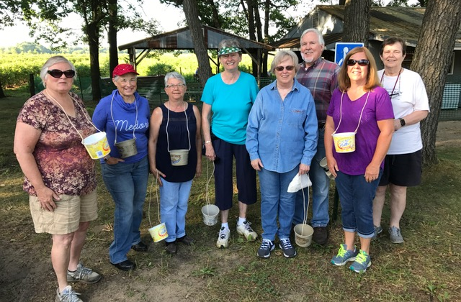

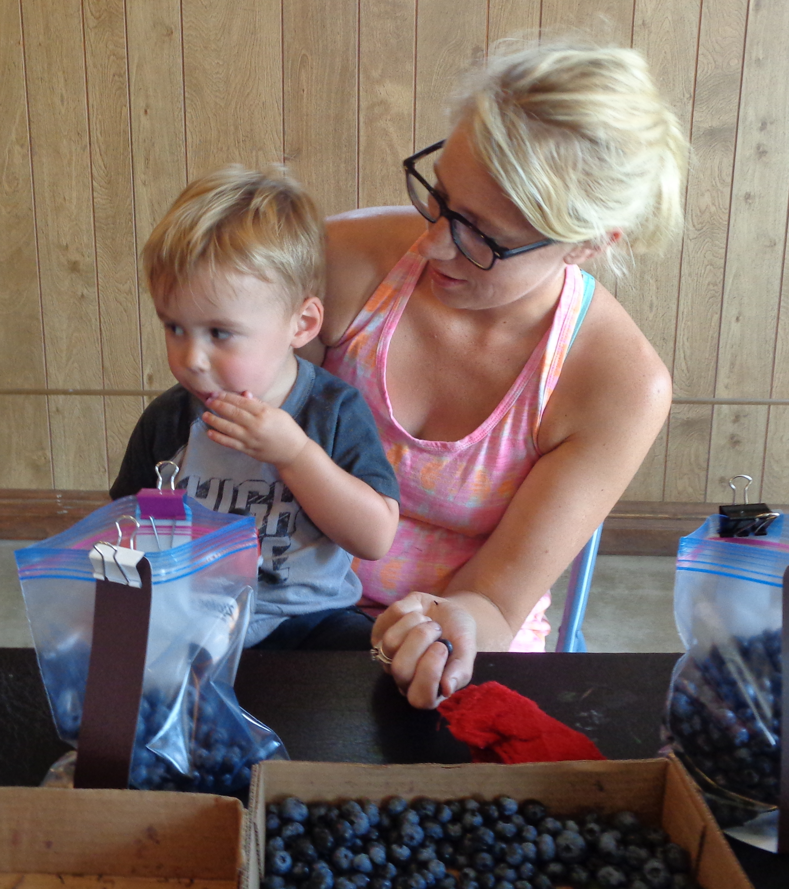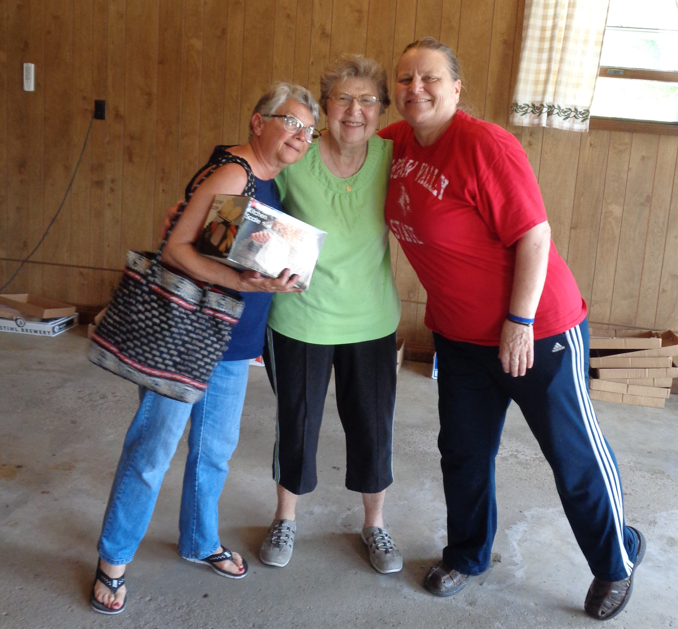

Scrapbook Committee Update

Marilee Applebee will be assuming the duties of Scrapbook Committee Chair. Mary Ann and I felt (after 12 years) it was time for some fresh ideas for our scrapbook layout. We will remain on the committee but mainly as photographers for the scrapbook, Omicron’s web site and Omicron’s Facebook page as we have been doing in the past. Sooo, please direct any newspaper articles, member news, etc. to Marilee. Her mailing address and e-mail can be found in the Omicron yearbook.

Thank you
Judy Hooper and Mary Ann Kennedy

Women in the Arts
39th Annual Creative Arts Retreat
Columbus Day Weekend, October 5 - 7, 2018
Lorado Taft Field Campus, NIU
Bev Madsen will bring registration forms on Tuesday, but all forms can also be found on the Lambda State site. If you haven't signed up, it will now be $160 for the weekend (or $110 for Saturday only), since it's now after the initial September 16th deadline. Applications will not be accepted after 9/29/18.

Personal Growth and Services
Janna Greanias sent out emails this summer about the school supplies we will be collecting. Stephanie Benson is starting a new position with River's Edge Academy (with the Grundy County Special Education Cooperative) and submitted a list of the things they are looking for to help the teachers there. Here it is again:

LOTS of Mechanical pencils
LOTS of number 2 pencils
LOTS of black pens and blue pens
Colored Markers
Clipboards
Paper Plates
Plastic Cups
Napkins
Post It Notes
Kleenex
Red pens
Highlighters
Full size pairs of scissors
Unbreakable rulers
Erasers
Pencil top erasers
Crayola crayons
Construction paper/different colors
Poster boards
Folding presentation boards
Loose leaf paper college and wide ruled
Bottles of white out
Sharpie markers fine point and bold
Fine point Expo markers
Dry erase board regular markers
Dry erase erasers
Dry erase board cleaner
Duct tape
Masking tape
Elmer's glue
Glue sticks
Disinfectant Clorox wipes
Hand sanitizer LOTS OF IT :)
Ziploc Gallon size storage bag
Ziploc quart size storage bag
Ziploc EXTRA BIG SIZE storage bags
Post its
Rolls of tape for tape dispenser
Index cards (all sizes)
2 pocket Folders
One subject notebooks

Finance

Proposed Budget
With this newsletter, you will also find the new proposed budget, as submitted by Bev Madsen. You will need to open it in Microsoft Excel.

Membership Dues
The deadline for paying your membership dues is the same as in the past: October 30th. Commencing in June of 2019, dues and fees will be paid no later than June 30th for the following year. You will be reminded of this change later in the year.

Active Dues: $86 Reserve Dues: $35

Monthly Treasurer’s Report
Balance as of 7/1/2018 $10,266.57

Receipts:
Aluminum Cans $27.00
Blueberries $3,574.00

Total Receipts $3,601.00
Total Funds available $13,867.57
Expenses:
Hooper/Blueberry Expenses $1,723.63
Harland Clark/Checks 58.65
Cal's Printing/Yearbooks 185.65
Bank Expenses: Statement 4.00
Total Expenses $1,971.93
Balance $11,895.64

2017-2018 Projects
Al Cans $27.00
Blueberries $1,850.37
Total $5,506.97

CD Information
Edward Jones $6,000 Three year @1.95
Cash: 328.31
Eureka Savings $1252.72 @ .75% maturing 11/10/18
Mendota State Bank: $2,142.79 2.0% for 14 mo.
Member News

You all must have had adventures over the summer! Please let me know what you did and send pictures, too!

Our next meeting will be Tuesday, September 18th at Pitsticks in Ottawa

Officer Initiation at 6pm
Dinner at 6:30pm for $21
Program: "Omicron in Wonderland"
Wear a crazy hat like the Mad Hatter!
Committee Reports: As Needed
As Always--Bring Cans!

