Delta Kappa Gamma
Lambda State
Keyhole Newsletter
October 2018

President’s Message:

Our October meeting will be a very important one for our chapter, and I hope that you will please try to attend the meeting. Pamela Rightsel, our state ambassador, will be attending the meeting. She will be helping us to develop our chapter goals for the next two years. There won't be any committee reports like we've done in the past. We will just have a regular business meeting. In order to save time, I have written a summary of the Fall Executive Board Meeting. If you have any questions, please bring them up at the meeting. Hope to see you there!

Mary Sue Myers, President

Minutes of the Regular Meeting of
Omicron Chapter
Delta Kappa Gamma Society International
September 18, 2018

We started tonight with the initiation ceremony of the new officers for the next biennium. We were fortunate to have State President Dr. Debra LeBlanc there to lead the ceremony.

Announcements
Thank you to Judy Hooper, Mary Ann Kennedy, and Jean Naretto for their leadership in the Blueberry Picking Adventures this summer.
Linda Ernst lost her mother just two weeks ago and then lost a good friend as well. Our condolences go out to Linda in this difficult time.
Mechthild Ferguson is on the mend and back at school after shoulder surgery.
Pledge, Blessing, and welcome to Dr. Debra LeBlanc!
Ways and Means Announcement: Judy Hooper introduced us to Schwan’s Cares as an online/phone order opportunity through Schwan’s. This can replace the Community Days. Details to follow as we learn more about how to use Schwan's.
Music and Program
Patty Hopkins lead us in song to the tune of "Let’s Go Fly a Kite" retitled “Let’s go to Wonderland.”
We then spent time in groups at three different stations of fun and creativity led by Teresa Cameron and her committee.
ONE: Writing up and decorating positive messages to Teresa’s kids.
TWO: Making Hats, in line with our Mad Hatter theme of the night, with lots of fun arts and crafts materials.
THREE: Playing Slap the Queen in groups of four and five.
Thank you to Teresa and all the members who made our Mad Hatter Tea Party such a fun night!

Business Meeting:
Co-president, Mary Sue Myers called the meeting to order. The minutes from the last meeting were accepted as printed, and the treasurer’s report filed for audit. Our books were audited in July by a committee and everything looked good.
Correspondence:
Thank you for the TCL Meeting breakfast in June from Dr. LeBlanc.
Thank you for the TCL Meeting breakfast from Linda Adcock, Leadership Development Chair
Thank you for the card from Esther Funk’s family for the flower and donation to the Reddick’s Library Fund.
New Business
The Creative Arts Retreat is coming up quickly in October! Bev brought forms for anyone who needed one.
The last state newsletter had information about a Legislative Seminar on Tuesday, October 20th. Norma Hedges would like to go, but she doesn’t want to go alone, so please let her know if you are interested!
Lambda State is looking for presentations for the State Convention. If you are interested, Mary Sue has the forms.
Our ambassador visit is next month, but we don’t have to make reports like we used to. Mary Sue is meeting with Pam Rightsel and will be learning what we need to prepare for her visit. Leadership development is one category, but we don’t have any ideas right now. Membership is another category we could improve upon. Bring a friend to a meeting and then learn what they liked or disliked. Programs: One idea is to use current teachers to present new ideas in the classroom. Marketing: Make magnets to advertise details of Omicron and put them up in our schools. We need to market ourselves to our fellow teachers in our schools to be able to get new members. Bev is going to look into finding a magnet source. Going forward with new ideas and new goals: We’ll get through the next month’s meeting and then we’ll start to brainstorm solid ideas to get some projects going in these areas. Bev noted that we don’t have any new initiates/inductees at this time for this year. This is the first time in 80 years that we haven’t had anyone. Note that we can initiate/induct new members at any time. We can invite nonmembers to our programs, perhaps to get them interested. Think about who hasn’t been coming to the meeting, and maybe we should reach out with a note to them.

Announcements/Committee Reports
Thanks to Kay Carlson for the yearbooks and all her work!

Bev Madsen presented us with copies of the budget for us to look over. We will vote on it at the next meeting.
Judy Hooper: Marilee Applebee will be the new Scrapbook person, so give her articles and pictures to her.
Thank you to everyone who contributed to the Blueberry Project this summer! We should be proud of the work we do and the pounds we pick!
Ways and Means
We have a new fundraiser with Schwan’s and Schwan’s Cares. First 45 days end on October 24th and earn us 20%. Oct 25th – Jan 22nd we get 5%. Place your order at Schwan’s.com. At Coupons and Fundraising, put the fundraiser ID of #42078. You’ll need to pay by credit/debit card when you order. The delivery date is part of the order process. If you don’t have an account, you can set up a new account. You’ll need a login/email and a password. You can also order by phone at 1-855-870-7208. Judy has a few catalogs if you would like to take one. The money will come to the chapter at the end of the campaign. If you share the number with family and friends, we can have them shop and benefit us. As Judy finds more information out, she’ll share with us in an email.

Singing of the Delta Kappa Gamma Song and the meeting was adjourned.

Respectfully submitted,
Marilee Applebee, Recording Secretary
Mary Sue Myers, President

Committee Reports and News

Fall Executive Board Meeting was held September 21-22, 2018, so here are some of the changes and new policies.

Rules Committee:
1. New members are inducted, not initiated. They are members as soon as they pay their dues.
2. New members must be employed.
3. Reserve members can be a junior or senior if they're in college and in an education program. (They can't be a full member if they are not employed.) $20 induction fee.
4. The chapter decides how new members are chosen, and it must be in writing.
5. Dues for next year will be paid by June 30th, 2019, and deposited by July 1st/2nd, 2019, The treasurer will send the money directly to International.

Society Business
1. Ambassadors will meet with chapters to discuss action taken relative to the established chapter goals.
2. Communication: Leadership conference at Bradley University will be on June 24-26, 2019. State Convention will be April 26-29, 2019 in Decatur, Illinois. Chapter treasurers will need to attend the convention for special training on the new system for dues payments and how to send the money to International.
3. Finance--The State needs a copy of the current chapter budget.
4. Membership--We received a copy of Form 6, death of a member.
5. Nominations--State is looking for people interested in serving as officers or on committees at the state level. November 2nd is the deadline for application. See Mary Sue or Bev if interested.
6. Educational Excellence--There will be a poster session at the state convention, and attendance at the convention is open to anyone who would like to attend.
7. International Affairs--There will be a trip to Cuba on March 20-27, 2019. The cost is $4000 and there are 25 places available.
8. Application deadlines for state monetary awards for chapter members: Scholarship--Jan 9, 2019. Josephine O'Neil--Feb 1, 2019. Foundation--November 1, 2018.

Ways and Means
At the September meeting a new fundraising project was introduced—Schwan’s Cares. I e-mailed the information to everyone. If you would like to participate and need that information again, please let me know.
Just a reminder—Omicron will receive 20% of all orders between now and October 24. Omicron will receive 5% of all orders between October 25, 2018 and January 22, 2019.
Thank you
Judy Hooper, Co-chair

Women in the Arts
57 Delta Kappa Gamma members attended the recent Creative Arts Retreat, including these two Omicron members who are showing off their hats!
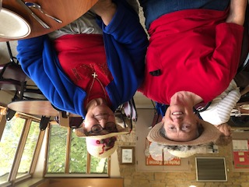

Personal Growth and Services

From Facebook: The school supplies were delivered to River's Edge Academy this week. Mrs. Ehrich was one happy camper! Another teacher was heard saying, "It's just like Christmas!" Thank you to Omicron Delta Kappa Gamma!
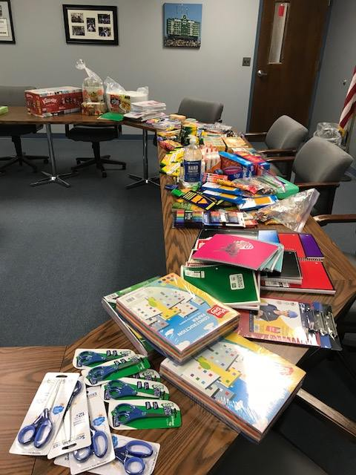

Food Pantry Donation Fund
Please bring in your $$$ donation for the food pantries. Give until it helps! Also put the word out for young ladies in their junior year of college to email jgreanias@ottawahigh.com for a scholarship application! Thank you! Janna Greanias

Finance

Membership Dues
The deadline for paying your membership dues is the same as in the past: October 30th. Commencing in June of 2019, dues and fees will be paid no later than June 30th for the following year. You will be reminded of this change later in the year.

Active Dues: $86 Reserve Dues: $35

Monthly Treasurer’s Report
Balance as of 9/12/2018 $11,895.64

Receipts:
Aluminum Cans $37.00
Dues $2,271.00
Reservations $567.00

Total Receipts $2,875.00
Total Funds available $14,770.64
Expenses:
Pitsticks/26 Dinners $546.00
Bev Madsen/Gifts/Pins $84.00
Bank Expenses: Statement 2.00
Total Expenses $632.00
Balance $14,138.64

2017-2018 Projects
Al Cans $64.00
Blueberries $1,850.37
Total $1,914.37

CD Information
Edward Jones $6,000 Three year @1.95
Cash: 328.31
Eureka Savings $1252.72 @ .75% maturing 11/10/18
Mendota State Bank: $2,142.79 2.0% for 14 mo.

Our next meeting will be Tuesday, October 16th at Pitsticks in Ottawa

Officer Initiation at 6pm
Dinner at 6:30pm for $21
Program: Travelogues and a Grant Money Presentation
Committee Reports: As Needed
As Always--Bring Cans!

